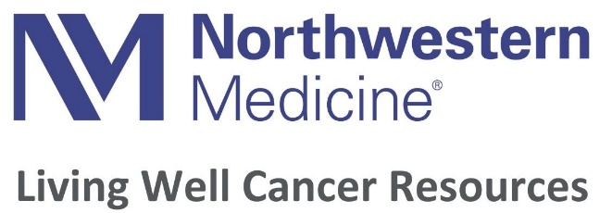

Wellness Programs and Services
Medical Release Form

We are requesting approval for your patient (first and last name) ________________________ DOB____/_____/______ to participate in our wellness programs.

The goals of our programs are to support healing, reduce stress and fatigue, and improve sleep.

Classes are designed specifically to help patients with cancer improve strength, flexibility, range of motion, circulation and balance as well as combat common treatment side effects such as osteopenia/osteoporosis, lymphedema, neuropathy and pelvic muscle weakness.

Please check the appropriate boxes below:
(Note: All classes are modified for individuals pre- or post-cancer treatment)

Yoga/Exercise ☐ May participate ☐ Not appropriate at this time
Facials ☐ May participate ☐ Not appropriate at this time
Massage/reflexology ☐ May participate ☐ Not appropriate at this time

_______________________________________ ____/_____/________
Physician or Health Care Provider Signature Date

_______________________________________
(Print provider name)

_______________________________________ ____/_____/________
Participant Signature Date

_______________________________________ _____________________
(Print participant name) Participant Phone #

_______________________________________
Participant Email Address

Please send completed form to:

· Email: Living Well Cancer Resources, info@livingwellcrc.org
· Fax: Living Well Cancer Resources, 630.262.1110

